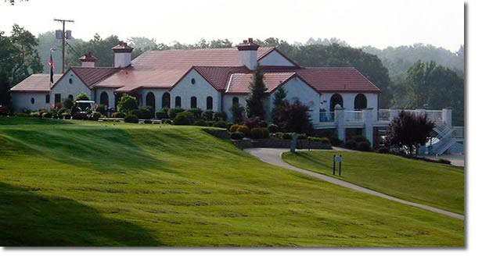
Regular: _______
Senior: _______
70+ years of age

ROLLING HILLS COUNTRY CLUB
701 Lakeview Drive, Paducah KY 42003 (270) 554-4508

MEMBERSHIP APPLICATION

REGULAR _______ SWIM & COURT _________ SOCIAL _________ NON-RESIDENT _________
Name Home Phone

Address

Email Address Cell Phone

Employment Work Phone

Spouse’s Name Cell

Employment Work Phone

Children at home or in college:

Name DOB Name DOB

Name DOB Name DOB

Application Status: New Member________ Former Member________ Child of Member ________

Signature of Applicant Signature of Rolling Hills Country Club Member RHCC Reference:
Applicant Date of Birth: ______________________ Applicant Date of Birth: ______________________

Mail to: Membership Chairperson, Rolling Hills Country Club, 701 Lakeview Drive, Paducah, KY 42003

*********************************

FOR ROLLING HILLS COUNTRY CLUB USE ONLY

Vote Contacted Initiation fee ACH

WP5

REGULAR _________ SWIM & COURT _________ SOCIAL _________ NON-RESIDENT _________
SWIM/TENNIS _________ SOCIAL

